Midterm Exam Instructions:

1. Your task is to create a responsive web design with three breakpoints - mobile, tablet, and desktop. The website should adjust its layout and design depending on the device's view port.
2. 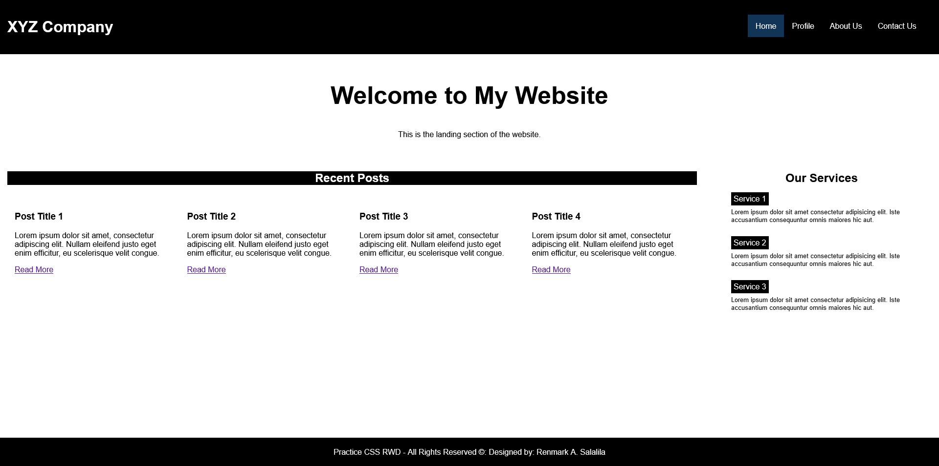Attached images will be provided to you to show what the website should look like in each view port. Ensure that your design matches the provided images.

**Desktop View:**

* Logo Left
* Nav Bar Right (with Active class)
* Welcome header and message must be centered
* Recent Post and Our Services shares the same row and aligned centered
* Recent Post articles should be in four (4) columns
* Our Services in one (1) column
* Footer should stick in the bottom and text should be aligned centered

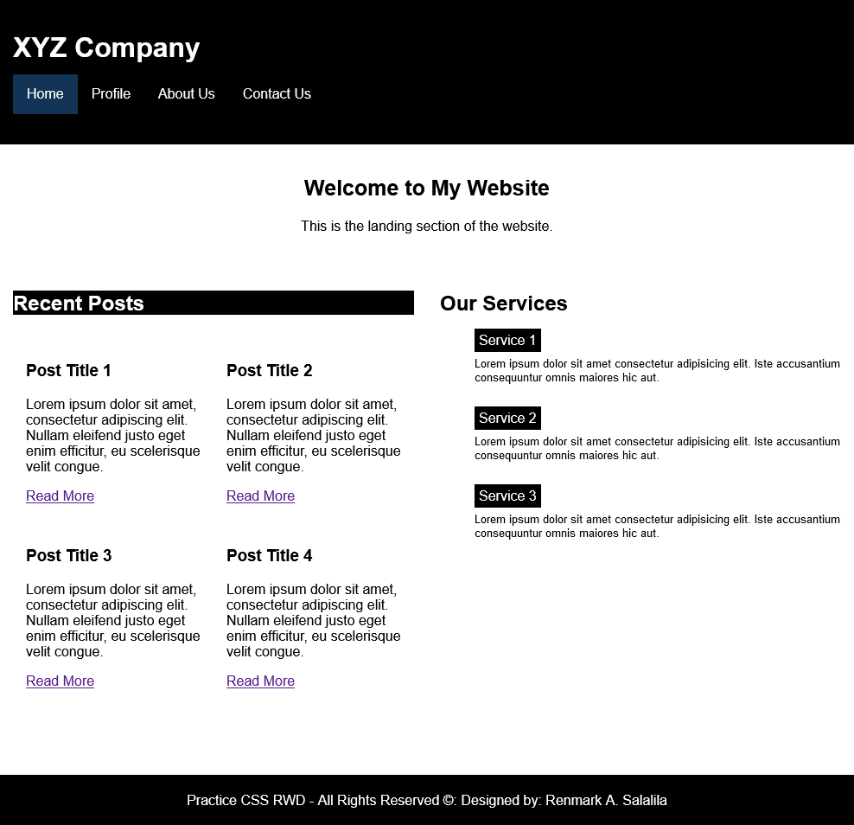

**Tablet View:**

* Logo Left
* Nav Bar Left (with Active class)
* Welcome header and message must be centered
* Recent Post and Our Services shares the same row and aligned left
* Recent Post articles should be in two (2) columns
* Our Services in one (1) column
* Footer should stick in the bottom and text should be aligned centered

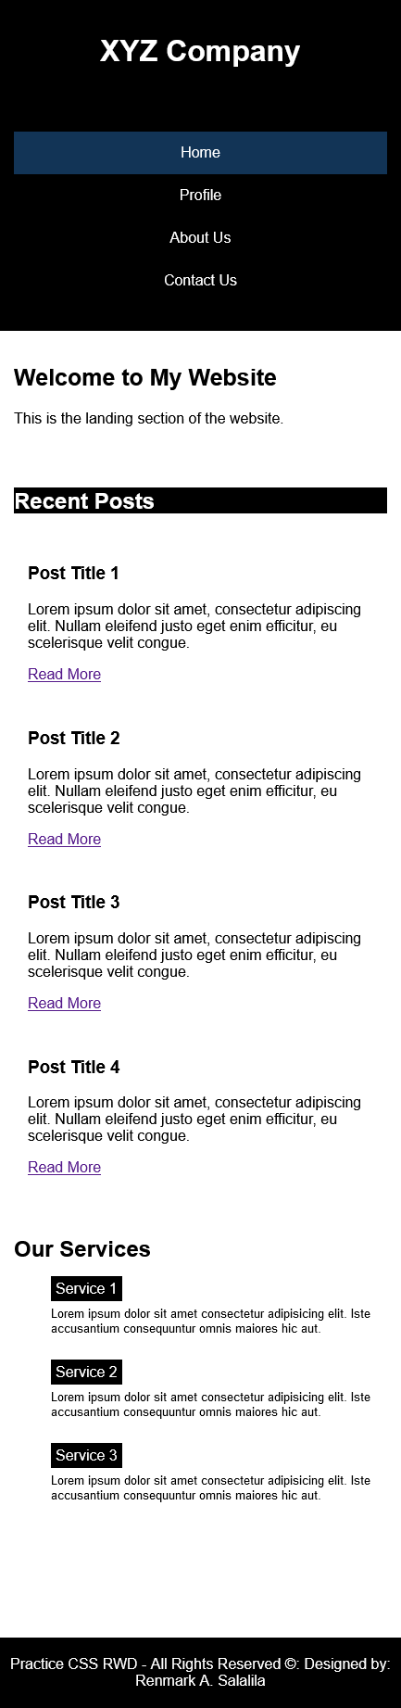**Mobile View:**

* Logo must be full width and centered
* Nav Bar full width and centered
* Welcome header and message must be aligned left
* Recent Post and Our Services shares the same row and aligned left
* Recent Post articles and Our Services should be one (1) column
* Footer should stick in the bottom and text should be aligned centered

1. Create custom CSS classes for making the background color black and text white. You will these classes in your design as needed.
2. Please note that the HTML code is already provided to you, and you should not make any alterations to it.
3. While it is not mandatory, using local git is advisable.
4. You are only allowed to work on the exam for 1 hour and 30 minutes.
5. Your grade will be determined based on the following criteria:

|  |  |  |
| --- | --- | --- |
| No. | Item | Points |
| 1 | Custom CSS color classes | 5 |
| 2 | Desktop View looks Exactly as defined | 10 |
| 3 | Tablet View looks Exactly as defined | 10 |
| 4 | Mobile View looks Exactly as defined | 10 |

Good luck!